CIS EJOURNAL

SEAT NO - 169 | STUDENT NAME – PRANAY RAORANE
CLASS: M.Sc. CS | SEMESTER: I | COURS CODE: RPSCSO506A
COURSE NAME - Practical of Cyber & Information Security
FACULTY IN-CHARGE - Ms. Priyanka Vaddepalli.

INDEX
SR. NO. | DATE | PARTICULAR | SIGNATURE
1 | 15/07/2025 | Security Goals
2 | 21/07/2025 | Operating System Security
3 | 28/07/2025 | Secure Communication
4 | 05/08/2025 | Database Security
5 | 06/08/2025 | Network Security
6 | 11/08/2025 | Cloud Security
7 | 12/08/2025 | IoT Security
8 | 25/08/2025 | Security Practices
9 | 07/09/2025 | Penetration Testing

Practical 01 Security Goals

1) 1. Confidentiality – Using Encryption (AES)
Encrypt & Decrypt a Message using cryptography module

Code:
from cryptography.fernet import Fernet
key=Fernet.generate_key()
cipher=Fernet(key)
message="Top Secret message!"
encrypted=cipher.encrypt(message.encode())
decrypted=cipher.decrypt(encrypted).decode()
print("Key;",key.decode())
print("encyrpted;",encrypted)
print("deecyrpted;",decrypted)
output:
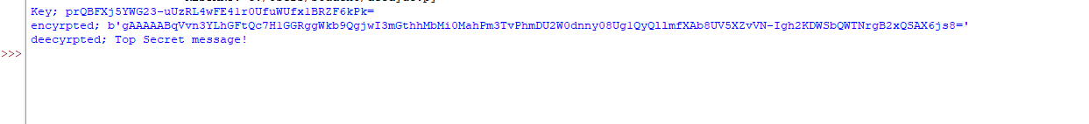
2. Integrity – Using Hashing (SHA-256)
Check if file or message is tampered

Code:
import hashlib
data="This is important"
hash1=hashlib.sha256(data.encode()).hexdigest()
tampered="this is important"
hash2=hashlib.sha256(tampered.encode()).hexdigest()
print("hash1;",hash1)
print("hash2;",hash2)
print("integrity verified?",hash1==hash2)
output:
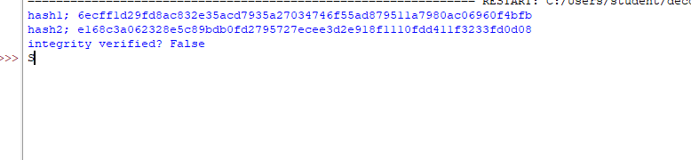
3. Availability – Simple Backup Script
Backup a file automatically

Code:
import shutil
original_file = r"C:\Users\student\Downloads\data.txt"
backup_file = r"C:\Users\student\Downloads\backup_data.txt"
shutil.copyfile(original_file,backup_file)
print("Backup completed!")
output:

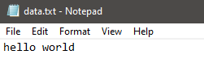
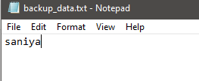
4. Authentication – Username & Password Check
Simple authentication system

Code:
users = {
"admin": "password123",
"user1": "hello123"
}

username = input("Enter username: ")
password = input("Enter password: ")

if users.get(username) == password:
print("Access granted")
else:
print("Access denied")
output:
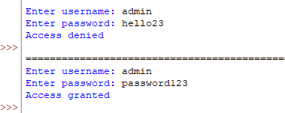
5. Non-Repudiation – Digital Signature Simulation
Sign and verify message (simplified)
Code:
import hashlib

message = "Approve $5000 transfer"
signature = hashlib.sha256(message.encode()).hexdigest()

received_message = "Approve $5000 transfer"
received_signature = hashlib.sha256(received_message.encode()).hexdigest()

print("Signature verified:", signature == received_signature)
output:
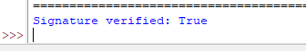
6. Accountability – Logging user actions
Example: Simple log system

Code:
import datetime

def log_action(user, action):
with open("audit_log.txt", "a") as log:
timestamp = datetime.datetime.now()
log.write(f"{timestamp} - {user}: {action}\n")

log_action("admin", "Logged in")
log_action("user1", "Viewed report")

print("Actions logged successfully!")
output:
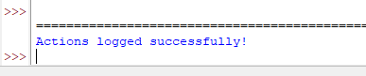
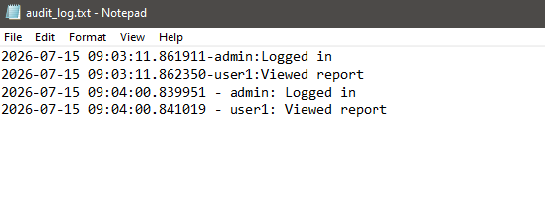
Implementing Security Goals in Python
Security Goal | Python Technique | Module Used
Confidentiality | AES Encryption | cryptography
Integrity | Hashing (SHA-256) | hashlib
Availability | Backups | shutil
Authentication | Password Verification | Built-in
Non-repudiation | Digital Signature (Hash) | hashlib
Accountability | Audit Logs | datetime, file I/O

Practical 02 Operating System Security
Aim: To perform OS security
Q.1) Key Concepts of OS Security
1. User Authentication (with Password Hashing)-
Learning: Secure password storage (no plain text), basic access control.
Code:
import hashlib
users={}
def hash_pass(passw):
return hashlib.sha256(passw.encode()).hexdigest()
def register(username,passw):
users[username]=hash_pass(passw)
print("Registered Successfully!")
def login(user,passw):
if users.get(user)==hash_pass(passw):
print("Access Granted!")
else:
print("Access Denied!")
register("admin","securepass")
login("admin","securepass")
login("admin","wrongpass")
Output:
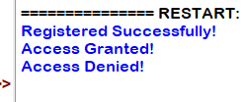

2. Role-Based File Access (Read/Write Permissions)
Learning: How OS restricts file operations based on user role.
Code:
permissions={
"admin":["read","write"],
"guest":["read"]
}
def access_file(user_role,action):
if action in permissions.get(user_role,[]):
print(f"{user_role} can {action} the file")
else:
print(f"{user_role} cannot {action} the file")
access_file("admin","write")
access_file("guest","write")
access_file("guest","read")
Output:
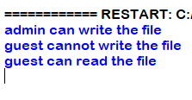
3. File Encryption with AES
Learn: How data encryption works at OS level (just like encrypted folders in
OS).
Code:
from cryptography.fernet import Fernet
key=Fernet.generate_key()
with open("filekey.key","wb") as filekey:
filekey.write(key)
def encrypt_file(filename):
with open("filekey.key","rb") as filekey:
key=filekey.read()
fernet=Fernet(key)
with open(filename,"rb") as file:
data=file.read()
encrypted=fernet.encrypt(data)
with open(filename,"wb") as file:
file.write(encrypted)
print("File Encrypted")
encrypt_file("example.txt")
Output:
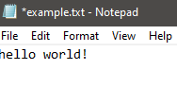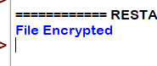

4. File Integrity Checker (Anti-tamper)
Learn: How OS detects unauthorized file changes (similar to antivirus tools).
Code:
mport hashlib
def get_fhash(filename):
with open(filename,"rb") as f:
return hashlib.sha256(f.read()).hexdigest()
og_hash=get_fhash("example.txt")
curr_hash=get_fhash("example.txt")
if og_hash==curr_hash:
print("File is intact")
else:
print("File has been changes")
Output:
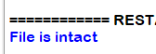
5. Basic IP Firewall Simulation
Learn: How firewalls block/allow IP traffic.
Code:
blocked_ips=["192.168.1.100","10.0.0.5"]
def check_access(ip):
if ip in blocked_ips:
print(f"Access Denied for {ip}")
else:
print(f"Access Granted for {ip}")
check_access("192.168.1.100")
check_access("8.8.8.8")

Output:
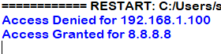

6. Activity Logging
Learn: How OS logs events for auditing and traceability.
Code:
import datetime
def log_activity(user,action):
with open("access_log","a") as logfile:
time=datetime.datetime.now().strftime("%Y-%m-%d %H:%M:%S")
logfile.write(f"[{time}]{user} -> {action}\n")
log_activity("admin","Accessed settings")
log_activity("guest","tried to delete files")
Output:
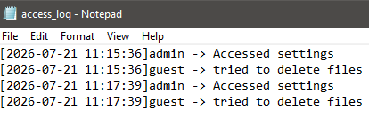

Q.2) Key Concepts of OS Memory
1. Simulate Memory Allocation (Static & Dynamic)
Learn: How memory is allocated linearly and fragmentation issues.
Code:
memory = [None] * 100
def allocate(process_id, size):
for i in range(len(memory) - size + 1):
if all(block is None for block in memory[i:i+size]):
for j in range(i, i+size):
memory[j] = process_id
return f" Allocated {size} blocks to {process_id} at {i}"
return " No sufficient memory"
def deallocate(process_id):
count = memory.count(process_id)
for i in range(len(memory)):
if memory[i] == process_id:
memory[i] = None
return f"Deallocated {count} blocks from {process_id}"
# Demo
print(allocate("P1", 10))
print(allocate("P2", 20))
print(deallocate("P1"))
Output:
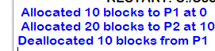

2. Monitor Real Memory Usage of Python Process
Learn: How to check real process memory like OS top or task manager.
Code:
import os, psutil
process = psutil.Process(os.getpid())
print(f" Current Memory Usage: {process.memory_info().rss / 1024**2:.2f} MB")
Output:
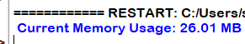
3. Garbage Collection Visualization
Learn: How Python uses automatic garbage collection unlike C.
Code:
import gc
import sys
a = [1] * (10**6) # Create large object
print("Memory used:", sys.getsizeof(a), "bytes")
del a # Delete variable
gc.collect() # Force garbage collection
print(" Garbage collected")
Output:
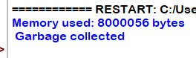

4. Paging Simulation (Basic)
Learn: How logical memory breaks into pages and maps to frames.
Code:
import math
def paging_simulator(process_size, page_size):
num_pages = math.ceil(process_size / page_size)
page_table = {f"Page {i}": f"Frame {i}" for i in range(num_pages)}
return page_table
# Example: 1024 KB process with 256 KB pages
table = paging_simulator(1024, 256)
for k, v in table.items():
print(f"{k} → {v}")
Output:
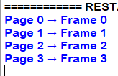

5. Memory Leak Simulation + Detection (for concept only)
Learn: What is memory leak & how to trace memory-heavy lines.
Code:
import tracemalloc
tracemalloc.start()
def leak_memory():
leaky_list = []
for _ in range(100000):
leaky_list.append("leak" * 1000)
return leaky_list
leak_memory()
snapshot = tracemalloc.take_snapshot()
top_stats = snapshot.statistics("lineno")
print(" Memory Leak Detected at:")
for stat in top_stats[:3]:
print(stat)
Output:
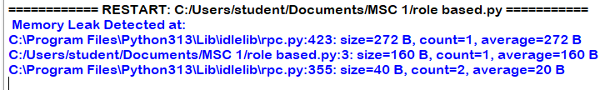

6. Simulated Buffer Overflow
Learn: Concept of writing out-of-bound and its impact.
Code:
def safe_array_write(array, index, value):
if index < len(array):
array[index] = value
return " Value written"
else:
return " Buffer Overflow Attempt!"
arr = [0] * 5
print(safe_array_write(arr, 2, 10))
print(safe_array_write(arr, 10, 10))
Output:
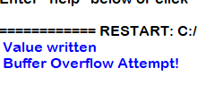

Practical 03 Secure Communication
RSA Key Generation (Sender &amp; Receiver)
Generate_keys.py
Code:
from cryptography.hazmat.primitives import serialization
from cryptography.hazmat.primitives.asymmetric import rsa

# --- 1. Generate Sender's Keys ---
sender_private = rsa.generate_private_key(public_exponent=65537, key_size=2048)
sender_public = sender_private.public_key()

with open("sender_private_key.pem", "wb") as f:
f.write(
sender_private.private_bytes(
encoding=serialization.Encoding.PEM,
format=serialization.PrivateFormat.TraditionalOpenSSL,
encryption_algorithm=serialization.NoEncryption(),
)
)

with open("sender_public_key.pem", "wb") as f:
f.write(
sender_public.public_bytes(
encoding=serialization.Encoding.PEM,
format=serialization.PublicFormat.SubjectPublicKeyInfo,
)
)

# --- 2. Generate Receiver's Keys ---
receiver_private = rsa.generate_private_key(
public_exponent=65537, key_size=2048
)
receiver_public = receiver_private.public_key()

with open("receiver_private_key.pem", "wb") as f:
f.write(
receiver_private.private_bytes(
encoding=serialization.Encoding.PEM,
format=serialization.PrivateFormat.TraditionalOpenSSL,
encryption_algorithm=serialization.NoEncryption(),
)
)

with open("receiver_public_key.pem", "wb") as f:
f.write(
receiver_public.public_bytes(
encoding=serialization.Encoding.PEM,
format=serialization.PublicFormat.SubjectPublicKeyInfo,
)
)

print(" All RSA keys generated and saved successfully:")
print(" - sender_private_key.pem & sender_public_key.pem")
print(" - receiver_private_key.pem & receiver_public_key.pem")

output:
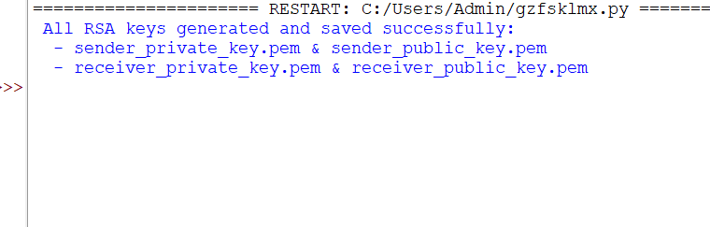
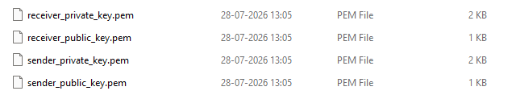

Sender.py
Run this script second. It loads the keys, encrypts the secret message for the receiver, signs it, and saves encrypted_message.bin and signature.bin.
Code:
from cryptography.hazmat.primitives import hashes, serialization
from cryptography.hazmat.primitives.asymmetric import padding

# 1. Load Receiver's Public Key (used to ENCRYPT)
with open("receiver_public_key.pem", "rb") as f:
receiver_public_key = serialization.load_pem_public_key(f.read())

# 2. Load Sender's Private Key (used to SIGN)
with open("sender_private_key.pem", "rb") as f:
sender_private_key = serialization.load_pem_private_key(
f.read(), password=None
)

# 3. Get message dynamically from user input
user_input = input("Enter the message you want to encrypt and sign: ")
message = user_input.encode("utf-8") # Convert string to bytes

# 4. Encrypt the message with Receiver's Public Key
encrypted_message = receiver_public_key.encrypt(
message,
padding.OAEP(
mgf=padding.MGF1(algorithm=hashes.SHA256()),
algorithm=hashes.SHA256(),
label=None,
),
)

# 5. Sign the message with Sender's Private Key
signature = sender_private_key.sign(
message,
padding.PSS(
mgf=padding.MGF1(hashes.SHA256()), salt_length=padding.PSS.MAX_LENGTH
),
hashes.SHA256(),
)

# 6. Save outputs to disk
with open("encrypted_message.bin", "wb") as f:
f.write(encrypted_message)

with open("signature.bin", "wb") as f:
f.write(signature)

print("\n Message encrypted and signed successfully.")
print("Saved 'encrypted_message.bin' and 'signature.bin'.")

output:
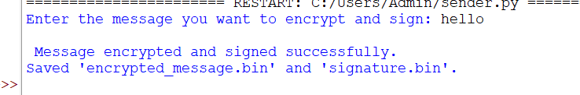
3) Receiver.py
It loads the files, decrypts the message using the receiver's private key, and verifies the sender's signature.

Code:
from cryptography.exceptions import InvalidSignature
from cryptography.hazmat.primitives import hashes, serialization
from cryptography.hazmat.primitives.asymmetric import padding

# 1. Load Receiver's Private Key (used to DECRYPT)
with open("receiver_private_key.pem", "rb") as f:
receiver_private_key = serialization.load_pem_private_key(
f.read(), password=None
)

# 2. Load Sender's Public Key (used to VERIFY SIGNATURE)
with open("sender_public_key.pem", "rb") as f:
sender_public_key = serialization.load_pem_public_key(f.read())

# 3. Load Encrypted Message and Signature from files
with open("encrypted_message.bin", "rb") as f:
encrypted_message = f.read()

with open("signature.bin", "rb") as f:
signature = f.read()

# 4. Decrypt the message
decrypted_bytes = receiver_private_key.decrypt(
encrypted_message,
padding.OAEP(
mgf=padding.MGF1(algorithm=hashes.SHA256()),
algorithm=hashes.SHA256(),
label=None,
),
)

original_message = decrypted_bytes.decode("utf-8")
print(f"\n Decrypted Message: '{original_message}'")

# DYNAMIC TAMPERING PROMPT
print("\n--- Signature Verification Options ---")
choice = input("Do you want to tamper with the message? (y/n): ").strip().lower()

if choice == "y":
altered_text = input("Enter the new/altered message: ")
message_to_verify = altered_text.encode("utf-8")
else:
message_to_verify = decrypted_bytes

# 5. Verify the signature
try:
sender_public_key.verify(
signature,
message_to_verify,
padding.PSS(
mgf=padding.MGF1(hashes.SHA256()),
salt_length=padding.PSS.MAX_LENGTH,
),
hashes.SHA256(),
)
print("\n Signature Verified: Message is authentic and untampered!")
except InvalidSignature:
print(
"\n SECURITY ALERT: Signature Verification Failed! The message was tampered with!"
)
Output:
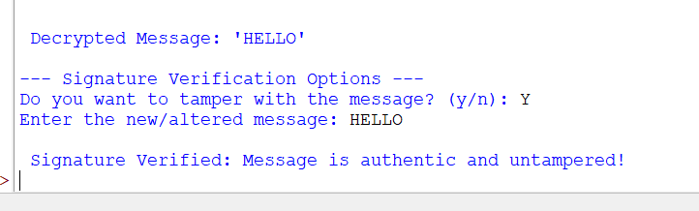

PRACTICAL 4 Database Security
Database Security
Aim:
To study and implement database security techniques using Python and SQLite, including input validation to prevent SQL Injection, password encryption using bcrypt, Role-Based Access Control (RBAC), and encryption of sensitive database fields using Fernet.
Theory:
Database security is the process of protecting a database from unauthorized access, misuse, and cyberattacks while ensuring the confidentiality, integrity, and availability of data.
In this practical, the following security techniques are implemented:
1. Input Validation (SQL Injection Prevention):
o SQL Injection is an attack where malicious SQL statements are inserted into user inputs.
o Using parameterized queries (?) separates user input from SQL commands, preventing attackers from modifying database queries.
2. Password Encryption using bcrypt:
o Passwords should never be stored in plain text.
o The bcrypt algorithm converts passwords into secure hashes with a random salt.
o During login, the entered password is verified against the stored hash using bcrypt.checkpw().
3. Role-Based Access Control (RBAC):
o RBAC restricts access based on the user's assigned role.
Cyber Information Security Archit Surve
o Different users receive different permissions, such as:
▪ Admin: Can view, add, modify, and delete records.
▪ Student: Can only view records.
o This improves database security by following the principle of least privilege. 4. Field Encryption using Fernet:
o Sensitive information is encrypted before being stored in the database using the Fernet symmetric encryption algorithm.
o Only users possessing the correct encryption key can decrypt and read the
stored data, ensuring confidentiality.
These techniques together help protect databases from common security threats, ensure secure authentication, and control user access effectively.
Code:
1. Securing Database with Input Validation (SQL Injection)
import sqlite3
conn = sqlite3.connect("students.db")
cursor = conn.cursor()
cursor.execute("""
CREATE TABLE IF NOT EXISTS users (
username TEXT,
password TEXT
)
""")
cursor.execute("INSERT INTO users VALUES ('admin', 'admin_password')") conn.commit()
username = input("Enter username: ")
password = input("Enter password: ")
query = f"SELECT * FROM users WHERE username = '{username}' AND password = '{password}'"
cursor.execute(query)
# Secure Version (Parameterized Query)
Cyber Information Security Archit Surve
# cursor.execute(
# "SELECT * FROM users WHERE username = ? AND password = ?",
# (username, password)
# )
result = cursor.fetchone()
print(result)
if result:
print("Login successful!")
else:
print("Invalid credentials!")
conn.close()
OUTPUT:
Case 1:
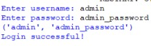
Case 2:
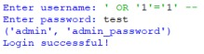
Case 3 (Parameterized Query):
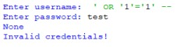
Cyber Information Security Archit Surve
2. Encrypting Sensitive Data in Database
import sqlite3
import bcrypt
conn = sqlite3.connect("secure_users.db")
cursor = conn.cursor()
cursor.execute("""
CREATE TABLE IF NOT EXISTS users (
username TEXT,
password BLOB
)
""")
conn.commit()
username = input("Enter username: ")
raw_password = input("Enter password: ")
hashed_password = bcrypt.hashpw(raw_password.encode(), bcrypt.gensalt())
cursor.execute(
"INSERT INTO users VALUES (?, ?)",
(username, hashed_password)
)
conn.commit()
login_user = input("Username to login: ")
login_pwd = input("Password to login: ")
cursor.execute(
"SELECT password FROM users WHERE username = ?",
(login_user,)
)
data = cursor.fetchone()
print(data)
if data and bcrypt.checkpw(login_pwd.encode(), data[0]):
print("Login successful!")
else:
print("Login failed!")
conn.close()
Cyber Information Security Archit Surve
OUTPUT:
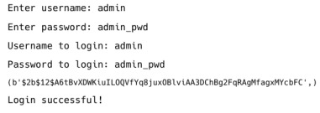3. Role-Based Access Control (RBAC)
import sqlite3
conn = sqlite3.connect("rbac.db")
cursor = conn.cursor()
cursor.execute("""
CREATE TABLE IF NOT EXISTS users (
username TEXT,
password TEXT,
role TEXT
)
""")
cursor.execute("INSERT INTO users VALUES ('admin', 'admin_pwd', 'admin')") cursor.execute("INSERT INTO users VALUES ('john', 'john_pwd', 'student')") conn.commit()
username = input("Enter username: ")
password = input("Enter password: ")
cursor.execute(
"SELECT role FROM users WHERE username = ? AND password = ?",
(username, password)
Cyber Information Security Archit Surve
)
user = cursor.fetchone()
if user:
role = user[0]
print(f"Login successful! Your role is: {role}")
if role == "admin":
print("Access granted to view, add, delete and modify records.") elif role == "student":
print("Access granted to view records.")
else:
print("Limited access.")
else:
print("Invalid credentials!")
conn.close()
OUTPUT:
Case 1:
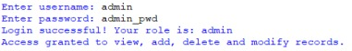Case 2:
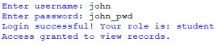
Cyber Information Security Archit Surve
4. Encrypting Entire Database Fields Using Fernet
from cryptography.fernet import Fernet
key = Fernet.generate_key()
cipher = Fernet(key)
data = "Confidential Information"
encrypted_data = cipher.encrypt(data.encode())
print("Encrypted data:", encrypted_data)
decrypted_data = cipher.decrypt(encrypted_data).decode()
print("Decrypted data:", decrypted_data)
OUTPUT:

PRACTICAL 5 Network Security
- User Registration + Login Module (SQLite + Hashlib)

Code:
import sqlite3
import hashlib
import secrets

def init_db():
conn = sqlite3.connect("users.db")
cursor = conn.cursor()

cursor.execute(
"CREATE TABLE IF NOT EXISTS users ("
"username TEXT PRIMARY KEY, "
"salt TEXT NOT NULL, "
"password_hash TEXT NOT NULL)"
)

conn.commit()
conn.close()

def hash_password(password, salt=None):
if not salt:
salt = secrets.token_hex(16)

hash_val = hashlib.pbkdf2_hmac(
"sha256",
password.encode(),
salt.encode(),
100000
)

return salt, hash_val.hex()

def register_user(username, password):
conn = sqlite3.connect("users.db")
cursor = conn.cursor()

cursor.execute(
"SELECT * FROM users WHERE username = ?",
(username,)
)

if cursor.fetchone():
conn.close()
return "Username already exists!"

salt, password_hash = hash_password(password)

cursor.execute(
"INSERT INTO users (username, salt, password_hash) VALUES (?, ?, ?)",
(username, salt, password_hash),
)

conn.commit()
conn.close()

return "User registered successfully!"

def authenticate_user(username, password):
conn = sqlite3.connect("users.db")
cursor = conn.cursor()

cursor.execute(
"SELECT salt, password_hash FROM users WHERE username = ?",
(username,)
)

result = cursor.fetchone()
conn.close()

if not result:
return False

salt, stored_hash = result
_, input_hash = hash_password(password, salt)

return input_hash == stored_hash

if __name__ == "__main__":
init_db()

print(register_user("alice", "secret_password"))
print(register_user("alice", "strong_password"))

print(
"Login success?",
authenticate_user("alice", "secret_password")
)

print(
"Login success?",
authenticate_user("alice", "wrong_password")
)
Output:
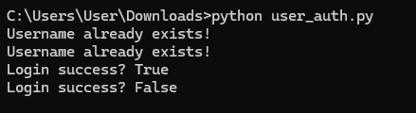
- Implement timestamp-based replay attack detection
Code:
import socket
from datetime import datetime, timedelta
from user_auth import authenticate_user, init_db

# Initialize database
init_db()

# Replay protection class
class MessageReceiver:

def __init__(self):
self.last_timestamp = None
self.replay_window = timedelta(seconds=30)

def verify_timestamp(self, timestamp_str):
try:
msg_time = datetime.strptime(
timestamp_str, "%Y-%m-%d %H:%M:%S"
)
now = datetime.utcnow()

if self.last_timestamp and msg_time <= self.last_timestamp:
return False, "Replay attack detected: Old timestamp."

if abs(now - msg_time) > self.replay_window:
return False, "Timestamp too old or too far in future."

self.last_timestamp = msg_time
return True, "Timestamp is valid."

except ValueError:
return False, "Invalid timestamp format."

# Server setup
server = socket.socket()
server.bind(("localhost", 9999))
server.listen(1)

print("Server listening on port 9999...")

conn, addr = server.accept()
print(f"Connected by {addr}")

# Step 1: Receive login details
username = conn.recv(1024).decode()
password = conn.recv(1024).decode()

if authenticate_user(username, password):

conn.send(b"AUTH_OK")
print("Authenticated:", username)

# Step 2: Replay Protection
receiver = MessageReceiver()

while True:
data = conn.recv(1024).decode()

if not data:
break

try:
msg, timestamp_str = data.split("||")

except ValueError:
conn.send(b"ERROR: Invalid message format")
continue

valid, response = receiver.verify_timestamp(timestamp_str)

print(f"[{username}] {msg} @ {timestamp_str} => {response}")

conn.send(response.encode())

else:
conn.send(b"AUTH_FAILED")
print("Authentication failed.")

conn.close()

Output:
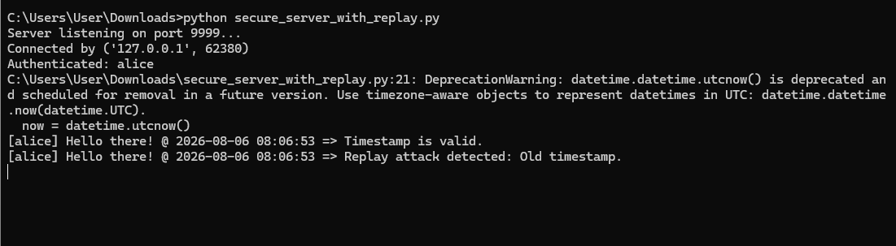

- Implement timestamp-based replay attack detection

Code:
import socket
from datetime import datetime
import time

client = socket.socket()
client.connect(('localhost', 9999))

# Step 1: Login
client.send(b"alice") # Username
time.sleep(1)
client.send(b"secret_password") # Password

auth_response = client.recv(1024)

if auth_response != b"AUTH_OK":
print("Login failed.")
client.close()

else:
print("Login successful.")

# Step 2: Send messages with timestamps
while True:
msg = input("Enter message (or 'exit'): ")

if msg == "exit":
break

timestamp = datetime.utcnow().strftime("%Y-%m-%d %H:%M:%S")
full_msg = f"{msg}||{timestamp}"

client.send(full_msg.encode())

server_response = client.recv(1024).decode()
print("Server:", server_response)

# Simulate replay attempt
time.sleep(2)
print("\n[Replaying same message...]")

client.send(full_msg.encode())
print("Server:", client.recv(1024).decode())

client.close()

Output:
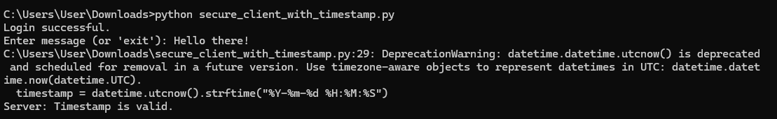

- Implement timestamp-based replay attack detection
Code:
import socket
from user_auth import authenticate_user, init_db
from cryptography.hazmat.primitives.ciphers.aead import AESGCM

# Constants
AES_KEY = bytes.fromhex("054f0c5c692ffa3e0d0fa7d156966812")
aesgcm = AESGCM(AES_KEY)

# Set up database
init_db()

server = socket.socket()
server.bind(('localhost', 8888))
server.listen(1)

print("File Server listening on port 8888...")

conn, addr = server.accept()
print(f"Connected by {addr}")

# Step 1: Login
username = conn.recv(1024).decode()
password = conn.recv(1024).decode()

if authenticate_user(username, password):

conn.send(b"AUTH_OK")
print("Authenticated:", username)

# Step 2: Receive Encrypted File
nonce = conn.recv(12) # AES-GCM nonce (must be 12 bytes)
filename = conn.recv(1024).decode()
file_size = int(conn.recv(1024).decode())

encrypted_data = b''

while len(encrypted_data) < file_size:
chunk = conn.recv(4096)

if not chunk:
break

encrypted_data += chunk

# Decrypt file data
try:
decrypted = aesgcm.decrypt(nonce, encrypted_data, None)

with open("received_" + filename, 'wb') as f:
f.write(decrypted)

conn.send(b"File received and decrypted.")
print(f"File saved: received_{filename}")

except Exception as e:
print("Decryption failed:", e)
conn.send(b"File decryption failed.")

else:
conn.send(b"AUTH_FAILED")

conn.close()

Output:
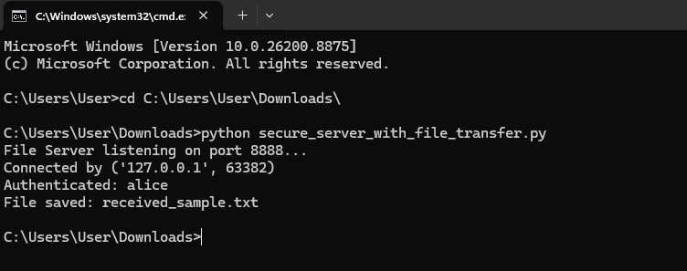

- Implement timestamp-based replay attack detection

Code:
import socket
import time
from cryptography.hazmat.primitives.ciphers.aead import AESGCM
import os

# AES Key must match server's
AES_KEY = bytes.fromhex("054f0c5c692ffa3e0d0fa7d156966812")
aesgcm = AESGCM(AES_KEY)

client = socket.socket()
client.connect(('localhost', 8888))

# Step 1: Login
client.send(b"alice") # Username
time.sleep(1)
client.send(b"secret_password") # Password

if client.recv(1024) != b"AUTH_OK":
print("Login failed.")
client.close()
exit()

print("Logged in. Ready to send file.")

# Step 2: Select and encrypt file
filename = "sample.txt" # Make sure this file exists

with open(filename, 'rb') as f:
file_data = f.read()

nonce = os.urandom(12) # GCM nonce
encrypted_data = aesgcm.encrypt(nonce, file_data, None)

# Step 3: Send file
client.send(nonce)
time.sleep(0.5)

client.send(filename.encode())
time.sleep(0.5)

client.send(str(len(encrypted_data)).encode())
time.sleep(0.5)

client.sendall(encrypted_data)

# Step 4: Receive server response
print("Server:", client.recv(1024).decode())

client.close()

Output:
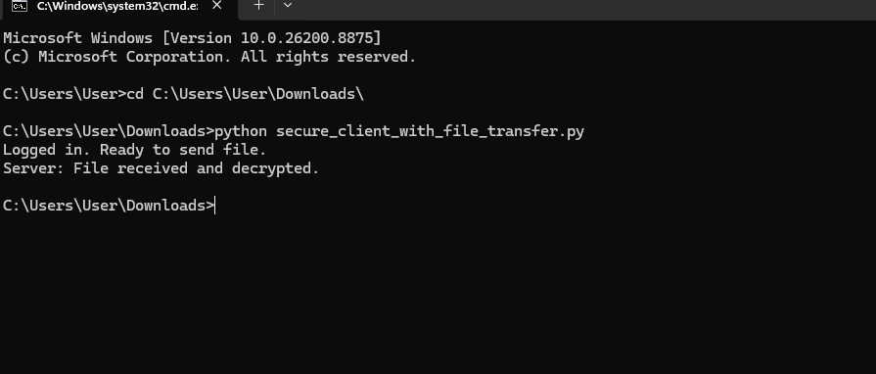

- Encrypted File Transfer over Same
Code :
from cryptography.hazmat.primitives.asymmetric import rsa
from cryptography.hazmat.primitives import serialization

# Generate RSA private key
private_key = rsa.generate_private_key(
public_exponent=65537,
key_size=2048
)

# Get the public key from the private key
public_key = private_key.public_key()

# Save the private key to a PEM file
with open("client_private.pem", "wb") as f:
f.write(
private_key.private_bytes(
serialization.Encoding.PEM,
serialization.PrivateFormat.TraditionalOpenSSL,
serialization.NoEncryption()
)
)

# Save the public key to a PEM file
with open("client_public.pem", "wb") as f:
f.write(
public_key.public_bytes(
serialization.Encoding.PEM,
serialization.PublicFormat.SubjectPublicKeyInfo
)
)

output:


- Replace password-based login with RSA public-key
Code:
import socket
import secrets
from cryptography.hazmat.primitives.asymmetric import padding
from cryptography.hazmat.primitives import serialization, hashes

# Load client public key
with open("client_public.pem", "rb") as f:
client_public_key = serialization.load_pem_public_key(f.read())

# Set up the server
server = socket.socket()
server.bind(('localhost', 7777))
server.listen(1)

print("RSA Server running...")

# Accept client connection
conn, addr = server.accept()
print("Connected by", addr)

# Step 1: Send challenge to client
challenge = secrets.token_bytes(32)
conn.send(challenge)

# Step 2: Receive signature from client
signature = conn.recv(512)

# Step 3: Verify the signature
try:
client_public_key.verify(
signature,
challenge,
padding.PKCS1v15(),
hashes.SHA256()
)

conn.send(b"AUTH_OK")
print("RSA Authentication Successful")

except Exception as e:
conn.send(b"AUTH_FAILED")
print("RSA Authentication Failed:", str(e))

# Close the connection
conn.close()

Output:
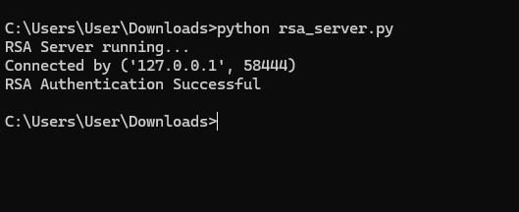
8) Replace password-based login with RSA public-key

Code:
import socket
from cryptography.hazmat.primitives.asymmetric import padding
from cryptography.hazmat.primitives import serialization, hashes

# Load private key
with open("client_private.pem", "rb") as f:
private_key = serialization.load_pem_private_key(
f.read(),
password=None
)

# Create a socket client
client = socket.socket()
client.connect(('localhost', 7777))

# Step 1: Receive challenge
challenge = client.recv(1024)

# Step 2: Sign the challenge
signature = private_key.sign(
challenge,
padding.PKCS1v15(),
hashes.SHA256()
)

# Step 3: Send signature to the server
client.send(signature)

# Step 4: Receive response from the server
response = client.recv(1024).decode()
print("Server:", response)

# Close the connection
client.close()

Output:
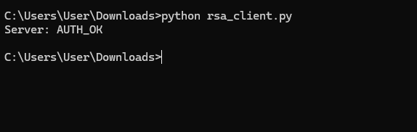

PRATICAL 6 Cloud Security

- Time-Limited Secure File Access Demo (Flask Based)
Code:
from flask import Flask, send_file, request, abort
from datetime import datetime, timedelta
import secrets

app = Flask(__name__)

# Store tokens and expiry time
TOKENS = {}

@app.route("/generate_link")
def generate_link():
token = secrets.token_urlsafe(16)

# Link valid for 30 seconds
expiry = datetime.now() + timedelta(seconds=30)

TOKENS[token] = expiry

return f"""
Temporary link created. Use it within 30 seconds:<br><br>
<a href="/download?token={token}">Download Link</a>
"""

@app.route("/download")
def download():
token = request.args.get("token")

if token in TOKENS:
if datetime.now() < TOKENS[token]:
return send_file("sample.txt", as_attachment=True)
else:
return "Link expired. Please generate a new one."

abort(403)

if __name__ == "__main__":
app.run(debug=True)
Output:

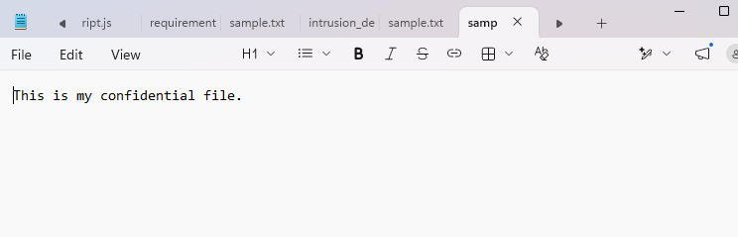
- Client-Side Encrypted Backup to Cloud (Zero Trust)

Code:
from cryptography.fernet import Fernet
import os
import shutil

# Create a simulated cloud folder
os.makedirs("cloud_backup", exist_ok=True)

# Step 1: Generate a secret key (AES)
key = Fernet.generate_key()
fernet = Fernet(key)

# Save the key securely (local file)
with open("aes.key", "wb") as kf:
kf.write(key)

# Step 2: Encrypt the file
def encrypt_file(file_path):
with open(file_path, "rb") as f:
data = f.read()

encrypted_data = fernet.encrypt(data)

encrypted_file_path = "enc_" + os.path.basename(file_path)

with open(encrypted_file_path, "wb") as ef:
ef.write(encrypted_data)

# Simulate cloud upload (just copying)
shutil.copy(
encrypted_file_path,
os.path.join("cloud_backup", encrypted_file_path)
)

print(f"Encrypted and uploaded: {encrypted_file_path}")

# Step 3: Run the encryption
if __name__ == "__main__":
input_file = "sample_file.txt"

# Create file if not present
if not os.path.exists(input_file):
with open(input_file, "w") as f:
f.write("Confidential Cloud Backup File")

encrypt_file(input_file)
output:
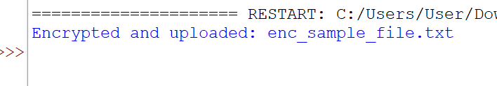
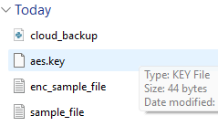
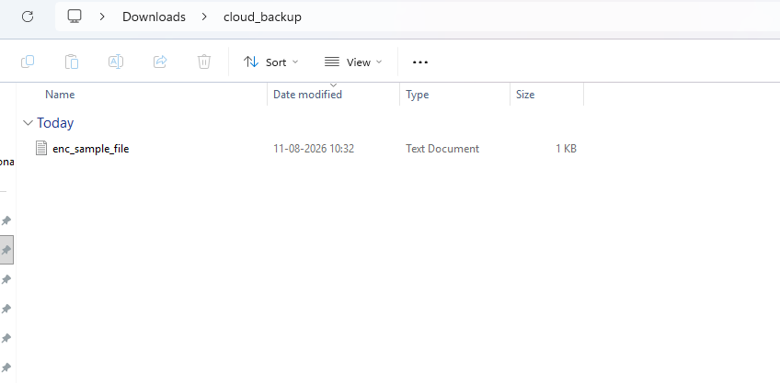
- Intrusion Detection System (IDS) for Cloud Access Logs
Code:
import json
from datetime import datetime

# Set your blacklisted IPs
blacklisted_ips = ["192.168.1.10", "10.0.0.5"]

# Load access logs
with open("access_logs.json") as f:
logs = json.load(f)

# Dictionary to count failed attempts
failed_attempts = {}

print("\nIntrusion Detection Log Analysis:\n")

for entry in logs:
user = entry["user"]
ip = entry["ip"]

time = datetime.strptime(
entry["timestamp"], "%Y-%m-%d %H:%M:%S"
)

status = entry["status"]

# Blacklist check
if ip in blacklisted_ips:
print(f"ALERT: Access from blacklisted IP {ip} by user '{user}'")

# Office hours: 08:00 to 18:00
if not (8 <= time.hour <= 18):
print(
f"Off-hour login attempt by '{user}' "
f"at {time.strftime('%H:%M')}"
)

# Failed login tracking
if status == "failed":
failed_attempts[user] = failed_attempts.get(user, 0) + 1

if failed_attempts[user] >= 2:
print(
f"User '{user}' has "
f"{failed_attempts[user]} failed login attempts!"
)

print("\nLog scan completed.\n")

json file
code:
[
{
"user": "Alice",
"ip": "192.168.1.10",
"timestamp": "2026-08-11 10:30:00",
"status": "success"
},
{
"user": "Bob",
"ip": "10.0.0.5",
"timestamp": "2026-08-11 22:15:00",
"status": "failed"
},
{
"user": "Bob",
"ip": "192.168.1.20",
"timestamp": "2026-08-11 23:00:00",
"status": "failed"
}
]

Output:
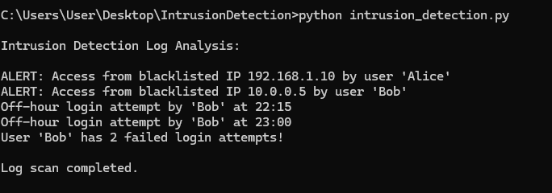

- Invisible Watermarking for Data Leakage Prevention

Code:
import hashlib
import os
import shutil

# Create simulated cloud folder
os.makedirs("cloud_upload", exist_ok=True)

# Function to add invisible watermark
def watermark_text(file_path, user_id):
with open(file_path, "r") as f:
content = f.read()

# Create a hash-based watermark from user_id
watermark = (
f"\n<!--USER-ID: "
f"{hashlib.sha256(user_id.encode()).hexdigest()}-->"
)

# Save watermarked file
watermarked_file = "wm_" + os.path.basename(file_path)

with open(watermarked_file, "w") as f:
f.write(content + watermark)

# Simulate cloud upload
cloud_path = os.path.join("cloud_upload", watermarked_file)
shutil.copy(watermarked_file, cloud_path)

print(f"File watermarked and uploaded to: {cloud_path}")

# Example usage
if __name__ == "__main__":
input_file = "sample_file.txt"

# Create sample file if not present
if not os.path.exists(input_file):
with open(input_file, "w") as f:
f.write("This is confidential content for cloud storage.")

# Simulate user uploading
watermark_text(input_file, user_id="user123")

output:
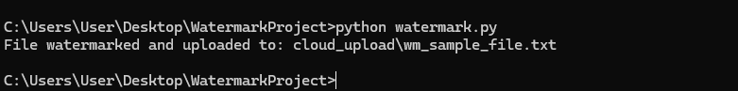

PRACTICAL 7 IOT Security
- AES Encryption for IoT Sensor Data
Code:

from Crypto.Cipher import AES
import base64

# AES requires a 16/24/32 byte key
key = b"ThisIsA16ByteKey"
cipher = AES.new(key, AES.MODE_EAX)

# IoT sensor data (example: temperature)
sensor_data = "Temperature: 28C"

# Encrypt
ciphertext, tag = cipher.encrypt_and_digest(sensor_data.encode())
nonce = cipher.nonce

print("Encrypted Data:", base64.b64encode(ciphertext).decode())

# Decrypt
cipher_dec = AES.new(key, AES.MODE_EAX, nonce=nonce)
decrypted_data = cipher_dec.decrypt(ciphertext).decode()

print("Decrypted Data:", decrypted_data)
Output:’
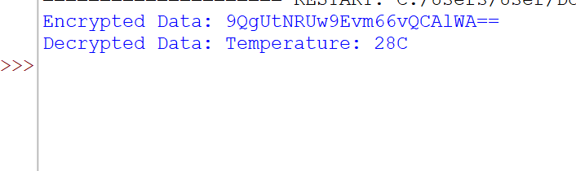
- HMAC for Data Integrity
Code:
import hmac
import hashlib

# Secret key shared between IoT device and server
secret_key = b"iot_secret_key"

# IoT message
message = b"Humidity: 70%"

# Generate HMAC
hmac_digest = hmac.new(
secret_key,
message,
hashlib.sha256
).hexdigest()

print("Message:", message.decode())
print("Generated HMAC:", hmac_digest)

# Receiver verification
received_hmac = hmac.new(
secret_key,
message,
hashlib.sha256
).hexdigest()

if hmac.compare_digest(hmac_digest, received_hmac):
print("Message is authentic")
else:
print("Message tampered!")
Output:
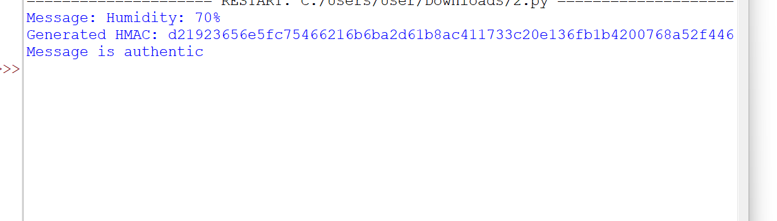
- MQTT Communication with TLS Security
Code:
import paho.mqtt.client as mqtt
import time

# Called when connected to MQTT broker
def on_connect(client, userdata, flags, reason_code, properties):
print("Connected with result code " + str(reason_code))
client.subscribe("iot/device1")

# Called when a message is received
def on_message(client, userdata, msg):
print("Received:", msg.topic, msg.payload.decode())

# Create MQTT client
client = mqtt.Client(
callback_api_version=mqtt.CallbackAPIVersion.VERSION2
)

# Assign callbacks
client.on_connect = on_connect
client.on_message = on_message

# Connect to MQTT broker
client.connect("test.mosquitto.org", 1883, 60)

# Start network loop
client.loop_start()

# Give time to connect
time.sleep(2)

# Publish sensor message
client.publish(
"iot/device1",
"Temperature Data: 25C"
)

print("Message published successfully")

# Give time for message to be sent/received
time.sleep(2)

# Stop network loop
client.loop_stop()

# Disconnect
client.disconnect()
Output:
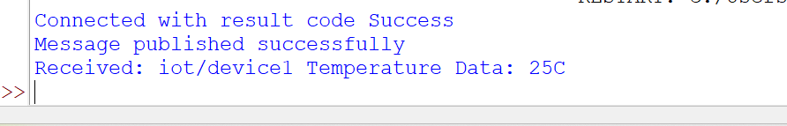

4) Packet Sniffing in IoT Traffic
code:
from scapy.all import sniff

def packet_callback(packet):
if packet.haslayer("IP"):
src = packet["IP"].src
dst = packet["IP"].dst

print(f"[IP Packet] {src} → {dst}")

if packet.haslayer("Raw"):
payload = packet["Raw"].load
print("Payload:", payload)

print("Sniffing IoT traffic... Press Ctrl+C to stop")

sniff(prn=packet_callback, count=10)
Output:
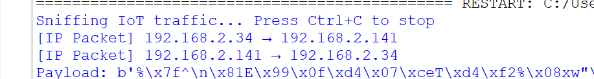
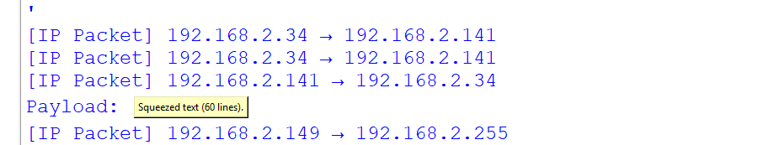

PRACTICAL 8 Security Practices
- CERTIFICATE COLLISION DEMONSTRATION
CODE:
toy_collision_demo.py
# toy_collision_demo.py

# Educational demo:
# Two different "certificate" byte-strings
# that produce the same value using a weak toy hash.

def toy_hash(b: bytes) -> int:
"""
Very weak toy hash:
sum of bytes modulo 256.

This is intentionally insecure and collision-prone.
"""
return sum(b) % 256

def make_base_certs():

# First certificate-like text
cert1_txt = """-----BEGIN CERTIFICATE-----
Subject: CN=Alice Example
Issuer: Test CA
PublicKey: AAAAB3NzaC1yc2EAAAADAQABAAABAQCu
-----END CERTIFICATE-----
"""

# Second certificate-like text
cert2_txt = """-----BEGIN CERTIFICATE-----
Subject: CN=Bob Example
Issuer: Test CA
PublicKey: AAAAB3NzaC1yc2EAAAADAQABAAABAQCu
-----END CERTIFICATE-----
"""

return cert1_txt.encode("utf-8"), cert2_txt.encode("utf-8")

def pad_to_match(hash_target: int, current_bytes: bytes) -> bytes:

cur = sum(current_bytes) % 256

needed = (hash_target - cur) % 256

if needed == 0:
return b''

return bytes([needed])

def main():

# Create two certificates
cert1, cert2 = make_base_certs()

# Calculate initial hashes
h1 = toy_hash(cert1)
h2 = toy_hash(cert2)

print("Initial toy hashes:")
print("cert1 hash:", h1)
print("cert2 hash:", h2)
print()

# Make cert2 hash equal to cert1
padding = pad_to_match(h1, cert2)

cert2_padded = cert2 + b"\n#PAD:" + padding

# Calculate hash again
h2_after = toy_hash(cert2_padded)

print("After padding cert2:")
print("cert1 length:", len(cert1),
"hash:", toy_hash(cert1))

print("cert2_padded length:", len(cert2_padded),
"hash:", h2_after)

print()

# Check whether files are actually identical
print("Are bytes identical?:", cert1 == cert2_padded)

# Check whether their toy hashes are equal
print(
"Do they collide under toy_hash?:",
toy_hash(cert1) == toy_hash(cert2_padded)
)

print()

# Show last bytes in hexadecimal
def show_tail(b):
tail = b[-40:]
return tail.hex()

print("tail(cert1) (hex):", show_tail(cert1))
print("tail(cert2_p) (hex):", show_tail(cert2_padded))

# Save the two files
with open("cert1_demo.pem", "wb") as f:
f.write(cert1)

with open("cert2_demo_padded.pem", "wb") as f:
f.write(cert2_padded)

print()
print("Wrote cert1_demo.pem and cert2_demo_padded.pem to disk.")

if __name__ == "__main__":
main()
output:
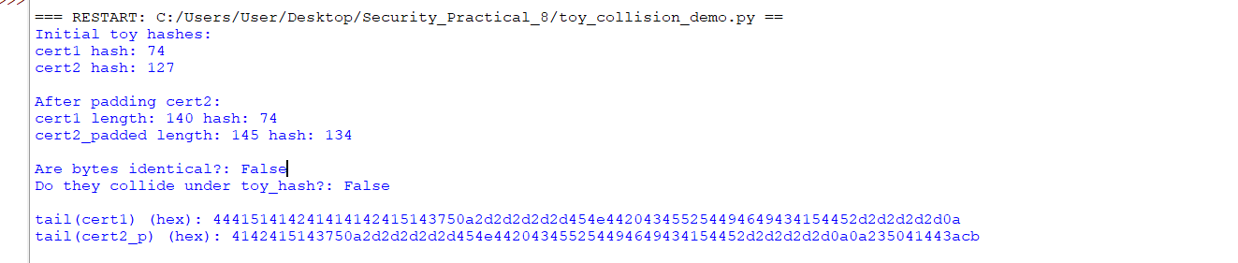
2) hash
Code:
import hashlib

message = "Hello Security Students".encode()

hash_digest = hashlib.sha256(message).hexdigest()

print("Message:", message.decode())
print("SHA256 Hash:", hash_digest)
Output:
3) mac
Code:
import hmac, hashlib

key = b'super_secret_key'
msg = b'Authenticate this message'

hmac_digest = hmac.new(key, msg, hashlib.sha256).hexdigest()
print("HMAC:", hmac_digest)

Output:

PRACTICAL 9 Penetration Testing

PART A: Port Scanner & Banner Grabbing Vulnerability Checker

1.] Aim : To implement a Python script that performs TCP port scanning, extracts service banners, and flags outdated software against a predefined vulnerability signature database.

Source Code:
from datetime import datetime
import socket

# Database of known vulnerable service banners
vulnerabilities = {
"Apache/2.2.8": "Outdated Apache version - vulnerable to CVE-2009-3555",
"OpenSSH_4.7": "Old OpenSSH version - possible remote exploits",
"Microsoft-IIS/6.0": "IIS 6.0 is deprecated - vulnerable to multiple attacks",
}

def scan_ports(target, ports):
open_ports = []
print(f"\n[*] Scanning {target} ...")
for port in ports:
try:
sock = socket.socket(socket.AF_INET, socket.SOCK_STREAM)
sock.settimeout(0.5)
result = sock.connect_ex((target, port))
if result == 0:
print(f"[+] Port {port} is OPEN")
open_ports.append(port)
sock.close()
except Exception:
pass
return open_ports

def grab_banner(ip, port):
try:
sock = socket.socket()
sock.settimeout(1)
sock.connect((ip, port))
banner = sock.recv(1024).decode().strip()
sock.close()
return banner
except Exception:
return None

def check_vulnerabilities(banner):
for vuln in vulnerabilities:
if vuln in banner:
return vulnerabilities[vuln]
return "No known vulnerability in database."

if __name__ == "__main__":
target = input("Enter Target IP (e.g., 127.0.0.1): ")
ports_to_scan = [21, 22, 23, 25, 80, 110, 143, 443, 3389]

start_time = datetime.now()

open_ports = scan_ports(target, ports_to_scan)

print("\n[*] Banner Grabbing and Vulnerability Check:")
for port in open_ports:
banner = grab_banner(target, port)
if banner:
print(f"\n[Port {port}] Service Banner: {banner}")
print(" -> " + check_vulnerabilities(banner))
else:
print(f"\n[Port {port}] No banner retrieved.")

end_time = datetime.now()
print("\n[*] Scan completed in:", end_time - start_time)

OUTPUT:

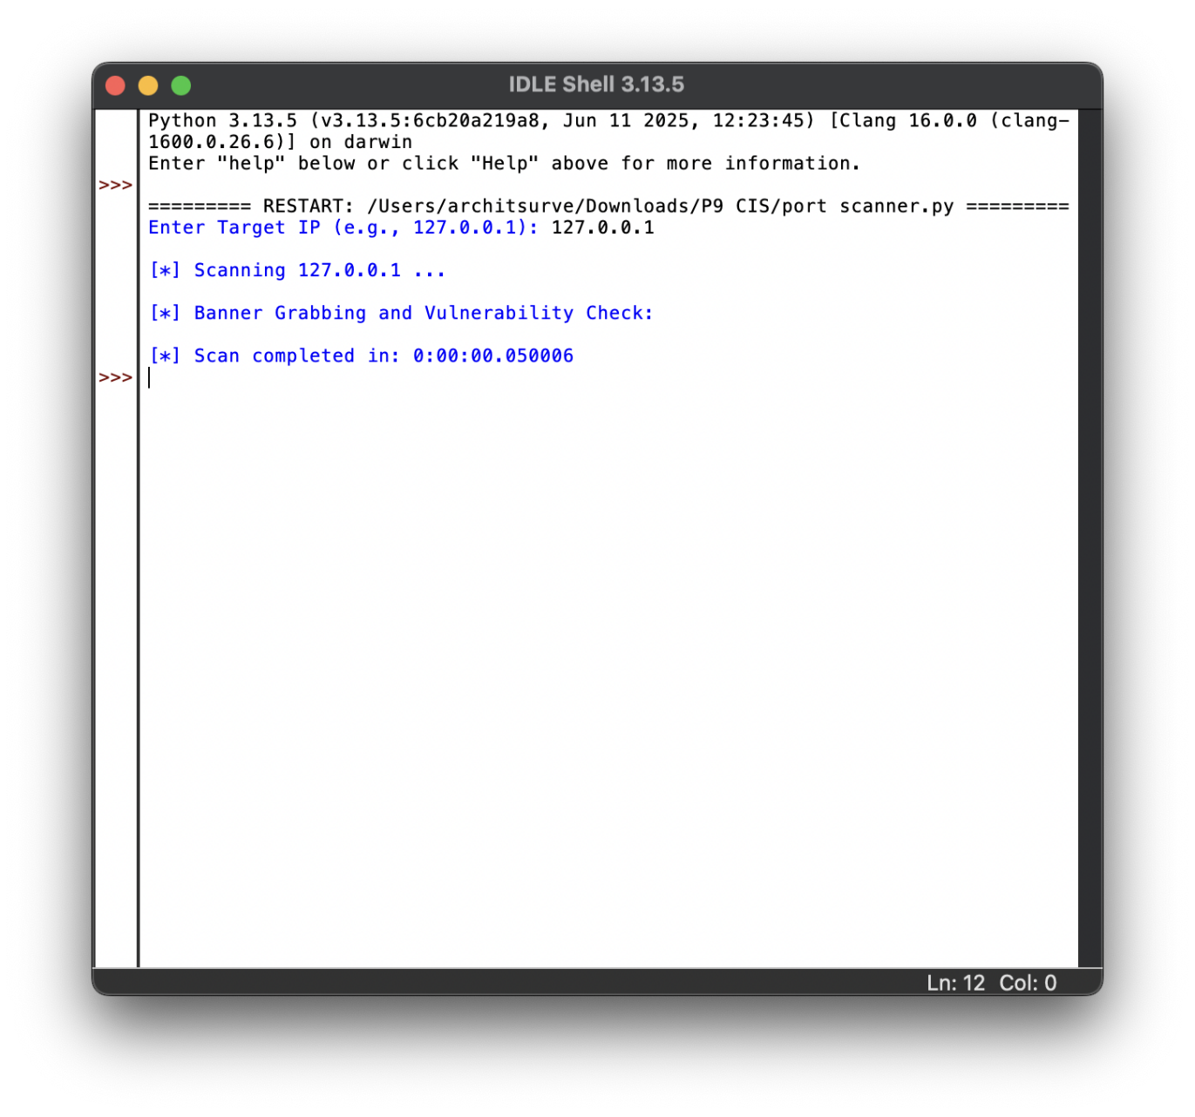

Part B: Comprehensive Penetration Testing Suite

Aim:
To build an integrated penetration testing tool covering port discovery, banner checking, FTP authentication brute-forcing, SQL injection vulnerability detection, and web directory brute-forcing

Source Code:

from datetime import datetime
import ftplib
import socket
import requests

# Known vulnerable service banners
vulnerabilities = {
"Apache/2.2.8": "Outdated Apache version - vulnerable to CVE-2009-3555",
"OpenSSH_4.7": "Old OpenSSH version - possible remote exploits",
"Microsoft-IIS/6.0": "IIS 6.0 is deprecated - vulnerable to multiple attacks",
}

def scan_ports(target, ports):
open_ports = []
print(f"\n[*] Scanning {target} ...")
for port in ports:
try:
sock = socket.socket(socket.AF_INET, socket.SOCK_STREAM)
sock.settimeout(0.5)
result = sock.connect_ex((target, port))
if result == 0:
print(f"[+] Port {port} is OPEN")
open_ports.append(port)
sock.close()
except Exception:
pass
return open_ports

def grab_banner(ip, port):
try:
sock = socket.socket()
sock.settimeout(1)
sock.connect((ip, port))
banner = sock.recv(1024).decode().strip()
sock.close()
return banner
except Exception:
return None

def check_vulnerabilities(banner):
for vuln in vulnerabilities:
if vuln in banner:
return vulnerabilities[vuln]
return "No known vulnerability in database."

def ftp_bruteforce(target, user, wordlist):
print(f"\n[*] Starting FTP Brute Force on {target}")
for password in wordlist:
try:
ftp = ftplib.FTP(target)
ftp.login(user, password)
print(f"[+] Found credentials: {user}: {password}")
ftp.quit()
return
except Exception:
print(f"[-] Failed: {user}: {password}")
print("[!] No valid credentials found.")

def sql_injection_test(url, param):
print(f"\n[*] Testing SQL Injection on {url}")
payloads = ["' OR '1'='1", "' OR 'x'='x", "'; DROP TABLE users; --"]
for payload in payloads:
new_url = f"{url}?{param}={payload}"
try:
r = requests.get(new_url, timeout=3)
if "error" in r.text.lower() or "syntax" in r.text.lower():
print(
f"[+] Possible SQL Injection vulnerability with payload: {payload}"
)
else:
print(f"[-] No error with payload: {payload}")
except Exception:
print("[-] Request failed.")

def dir_bruteforce(url, wordlist):
print(f"\n[*] Starting Directory Brute Force on {url}")
for word in wordlist:
test_url = f"{url}/{word}"
try:
r = requests.get(test_url, timeout=3)
if r.status_code == 200:
print(f"[+] Found directory: {test_url}")
except Exception:
pass

if __name__ == "__main__":
target = input("Enter Target IP (e.g., 127.0.0.1): ")
ports_to_scan = [21, 22, 23, 25, 80, 110, 143, 443, 3389]

start_time = datetime.now()

# Step 1: Port Scanning
open_ports = scan_ports(target, ports_to_scan)

# Step 2: Banner Grabbing
print("\n[*] Banner Grabbing and Vulnerability Check:")
for port in open_ports:
banner = grab_banner(target, port)
if banner:
print(f"\n[Port {port}] Service Banner: {banner}")
print(" -> " + check_vulnerabilities(banner))
else:
print(f"\n[Port {port}] No banner retrieved.")

# Step 3: FTP Brute Force
ftp_wordlist = ["1234", "admin", "password", "toor"]
ftp_bruteforce(target, "admin", ftp_wordlist)

# Step 4: SQL Injection Test
sql_injection_test("http://127.0.0.1/vulnerable.php", "id")

# Step 5: Directory Brute Force
wordlist = ["admin", "login", "test", "uploads"]
dir_bruteforce("http://127.0.0.1", wordlist)

end_time = datetime.now()
print("\n[*] Scan completed in:", end_time - start_time)
OUTPUT:


